
Name: Abdul Samad
Program: BSSE Group A
Semester: 5th
Date: October 15, 2026
*-----------------------------------------------*

Lab Task 6
Task 1:

Date Validator:

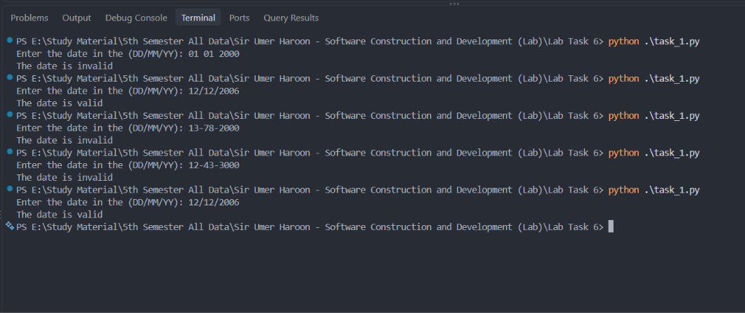

Task 2:

Phone Number Validator:

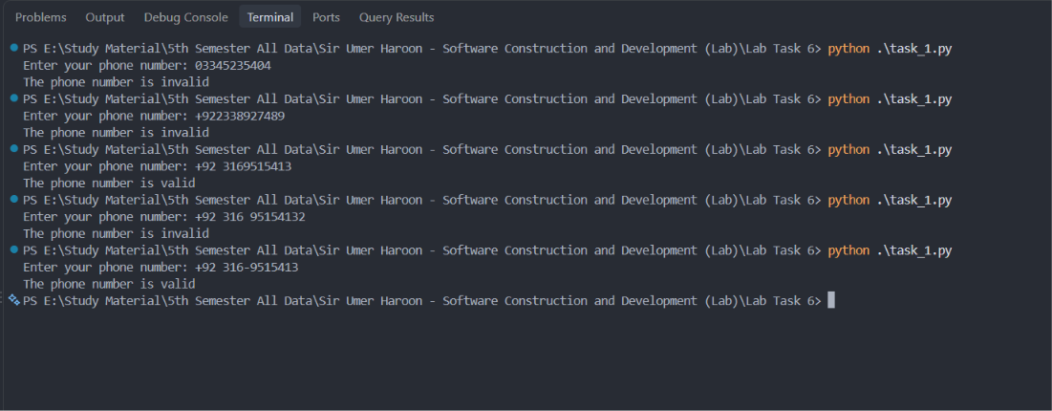

Task 3

*-----------------------------------------------*

The End

